Converting PHD Settings on Malvern PANalytical XRDs

If the samples contain any of the atoms the fluoresce under copper radiation (Fe, Mn, Co, Cr), then it might be advantageous to change the Proportional Height Detection on the Detector.

To do this, follow these steps:
- Log into Data Collector as you normally would.
- Go to the Diffracted Beam Optics

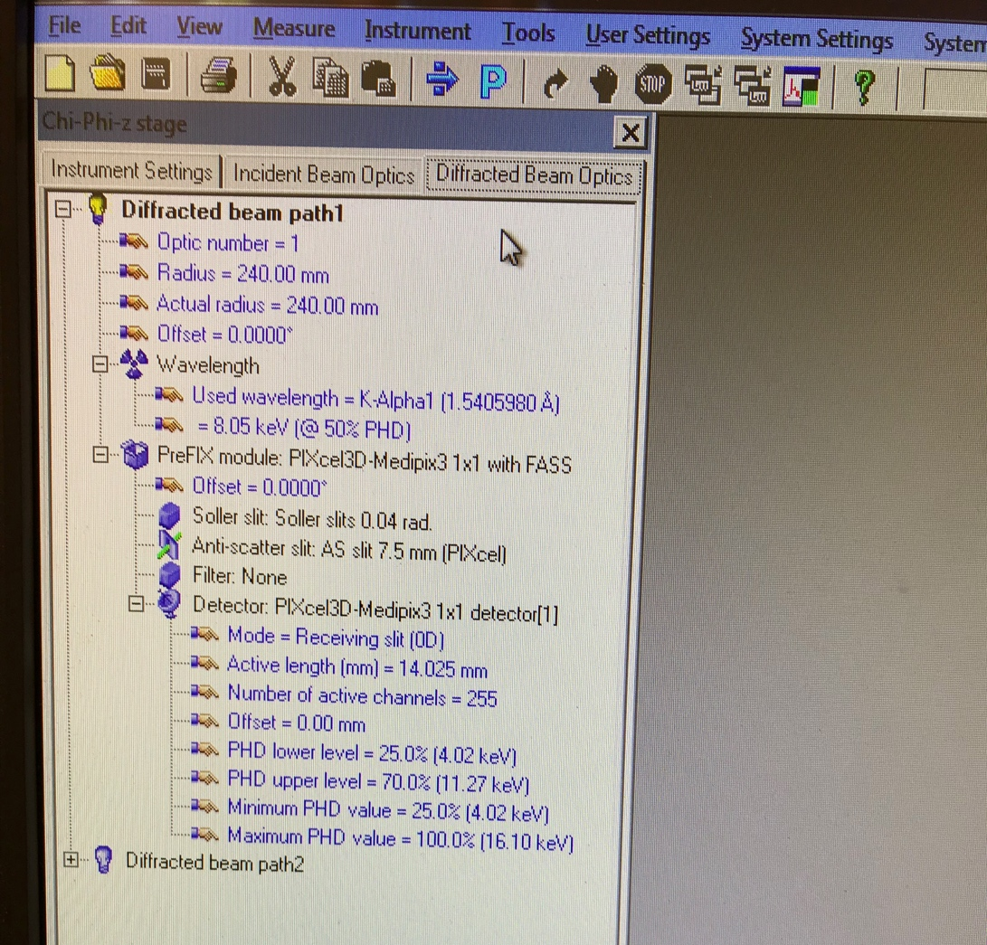

- Under this tab, click on detector (this is true on both the alpha-1 as well as the Empyrean and the following window should open up.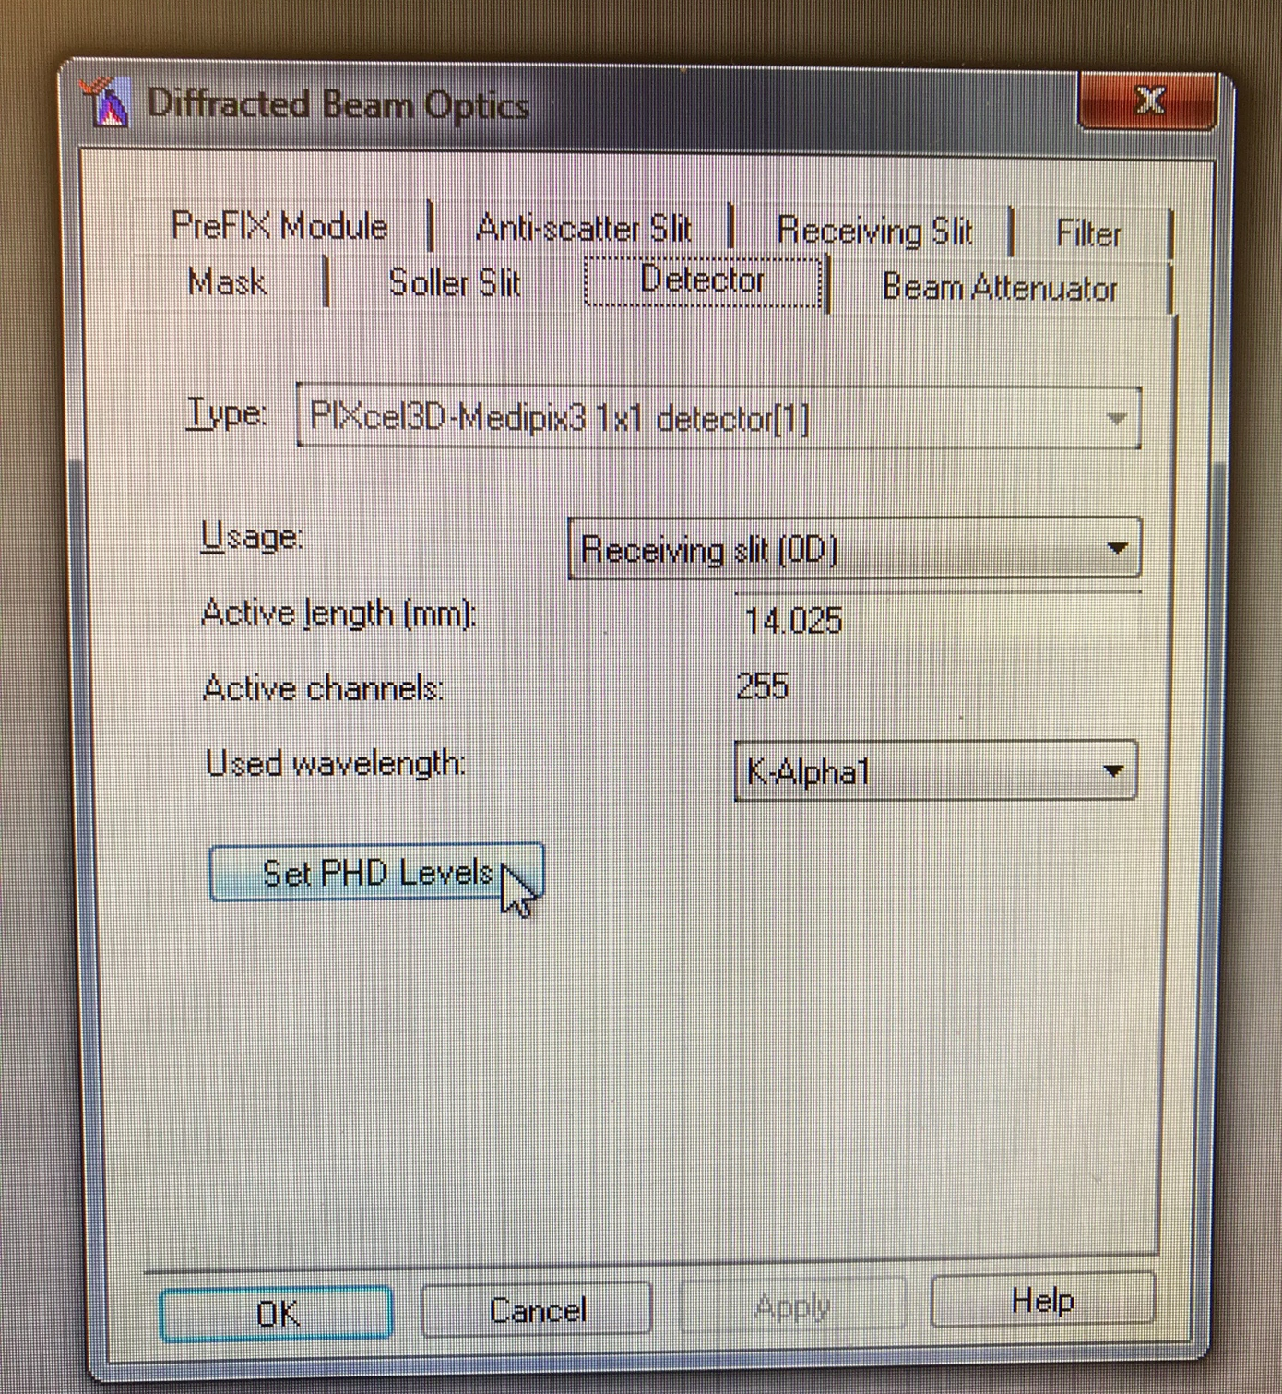
- Click on Set PHD Levels.

On the Empyrean, default is 25% for the Lower Energy Level. For a sample containing a high amount of an atom that fluoresces, adjust the lower level to 45% to start. Depending on the amount of material you have present, you might want to optimize that number upwards to 54%. Every sample will be different but 45% is a good starting point.

Note: If you change this value, it will stay the same every time you log in. If are you working with samples that contain Iron (for example) and the next week you come in with a sample that does not, your counts will be great reduced! Make sure to change this value back if doing so, or create a separate account with a different PHD Level (contact staff to do this).

