Time-of-Flight Secondary Ion Mass Spectrometry

(ToF-SIMS)

The IONTOF Time-of-Flight Secondary Ion Mass Spectrometry (ToF-SIMS) system uses ion beams to directly chemically image materials. Atomic weights from 1 up to >10,000 amu (i.e., hydrogen up to large molecules) can be detected with a mass resolution, dm/m, up to 10,000. Analysis depths range from the surface (tens of angstroms) in static SIMS mode, down to depths of several microns. The system can detect trace elements down to concentrations of a few parts per million of a monolayer, making it the only standard technique capable of dopant-level surface and depth profile characterization. It can produce chemical maps and 3-D chemical reconstructions with single-nanometer depth resolution and 0.1-micron lateral resolution.

Some useful links:

<http://serc.carleton.edu/research_education/geochemsheets/techniques/ToFSIMS.html>

<http://pprco.tripod.com/SIMS/Theory.htm>

# sidebar.PNGInitial Checks

Usually the software will be running when you log into the system. The System Panel, which shows the system status and control shortcuts, should be open on the right hand side of the screen (🡪).

Bring up the settings menu by clicking setting icon.PNG under Instrument set-up. Click on Vacuum to bring up the various system pressures. Typical pressures are:

* Main Normal: 1–5E-8, Max: ~3E-6 just after loading
* Loadlock Normal: ~1.5E-6
* Buffer Normal: <UnderRange>
* LMIG Normal: <UnderRange> to 1E-8 during operation
* DSC-S Normal: <UnderRange> to mid E-9, Max: 4-5E-5 in operation
* Analyzer <UnderRange> to 2E-8
* Drag <UnderRange>

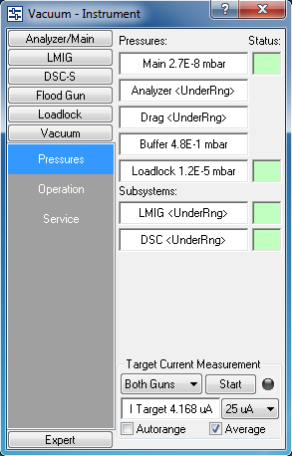

Note the system vacuum parameters in the onscreen log file. In the System Panel and other detailed operation windows, all controls/indicators should show green backgrounds at startup and during operation. **IF NOT, IMMEDIATELY STOP your work and contact a trainer.**

# Loading a Sample

When you begin, the sample holder should be in the loadlock. The sample holder, tweezers, and screwdriver need to be kept extremely clean as any contamination will show in the analysis later-on. The door handle, loadlock arm and switches, and the mounting block are all considered dirty and should be maneuvered with the back of the hand only.

1. On the transfer arm, push the Loadlock switch to the “OFF” position. On the chamber door, tilt the handle towards yourself towards yourself.
2. Put on gloves. Consider the inside of your hand and fingertips clean. Do not touch anything except the tweezers, screwdriver, and sample holder with them.
3. Once the loadlock is vented, swing open the door using the back of your hand. Push the black sheath on the transfer arm forward (using the back of your hand). Remove the sample holder by twisting 90 degrees (hold regularly) and mount the sample holder into the mounting block.
4. Close the door and push the loadlock switch to “ON”. Press the door closed and use the lever to maintain pressure to seal the loadlock. Wait until you hear the turbopump accelerate.
5. Loosen the screw(s) partially for the areas where you want to load samples. Use a spacer of appropriate thickness to take up extra space in the backmount sample holder. Tighten the screw(s) that you have loosened and check all of the others.
6. MAKE SURE THAT ALL SCREWS ARE TIGHTENED!! Failure to do so could incapacitate and/or damage the system and will result in loss of permission to use the system. Use the nitrogen gun to – gently – dust off the samples and sample holder.
7. Push the Loadlock switch to “OFF” to vent the loadlock. Open the door. Place the sample holder back on the load arm. Pump the loadlock as in line 4 above.
8. 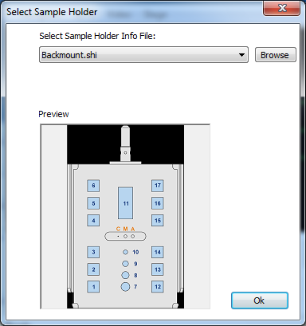Wait for the loadlock pressure to reach the ~3E-6 mbar range. Check to make sure the stage is in the transfer position by pressing icon-navigator.PNG under Navigation. Select “Transfer” and click “Go”.
9. Press the Gate switch on the transfer arm to “OPEN”. Slide the black sheath with the stage into the analysis chamber until you feel the stage lock in. Turn 90 degrees to release the stage and retract the arm.
10. Press the Gate switch to on the transfer “CLOSE”.
11. Select the type of stage from the Sample Holder dialog box.

# Connect to the SYSTEM

Click on the power icon.PNG button on the system panel. Turn on the Analyzer, LMIG, and Sputter gun (If doing depth profiles) by checking the boxes next to each.

Next we need to bring up the control windows for each component. Open the settings panel setting icon.PNG and Shift+Click on Analyzer, LMIG, and DSC. Images for these panels are below:

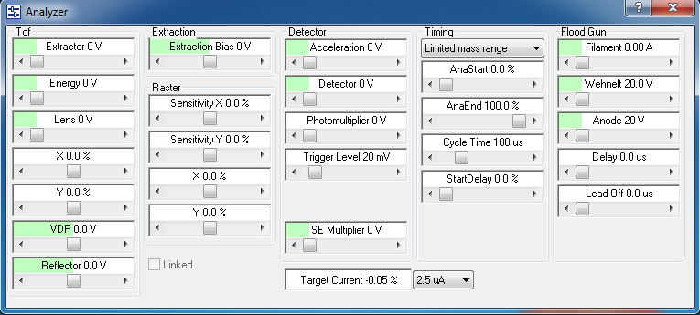

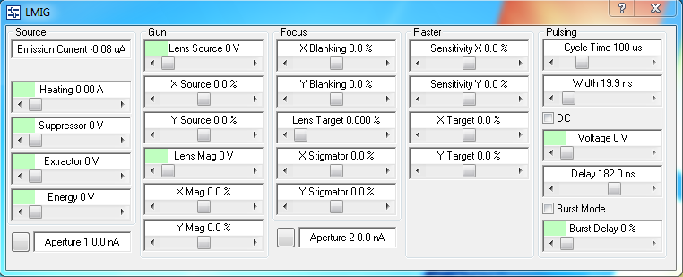

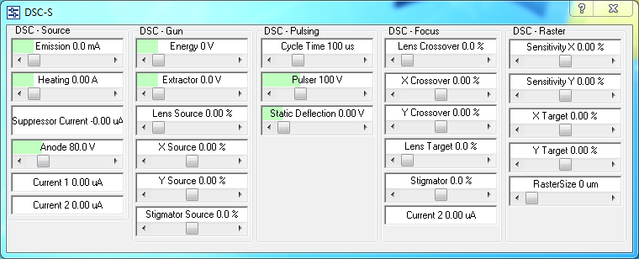

These subsystems will be brought up in the following order:

1. DSC
2. LMIG
3. Analyzer (as part of LMIG startup)

# Sputter Gun (DSC-S) Startup

The Sputter gun is used for depth profiling. If you are not planning to use the sputter gun, you may skip to the next section. The two ions available for sputtering are Cs and O. **THE FOLLOWING STEPS ARE CRITICAL TO PRESERVING THE SPUTTER SOURCES.**

If using Oxygen:

1. **Make sure** that it has been at least 30 minutes since the Cs source was powered off.
2. Briefly open then close the valve on the DSC oxygen bottle, – there are two bottles so be certain to choose the correct one – and **make sure** that the upper gauge on the regulator is set to 10 psi.

If using Cesium:

1. **Make sure** that it has been at least 30 minutes since the oxygen sputter source was used.
2. **Make sure** that the DSC pressure reading is below 5E-8 mbar.

For either sputter gun:

* Click loadsettings icon.PNG under Settings in the System Panel.
* Navigate to C:\Program Files\ION-TOPF\Surface Lab 6\settings\DSC. You can choose between several different acceleration voltages for the Cs or O ions. Higher energy ions give faster sputter rates but lower depth resolution. Open the file for the desired ion type and energy. You will see a popup window asking for which component you want to load the selected settings. Select “All” or “Selected”.

The O sputter source will take about 10 minutes to stabilize and should have an emission current of 2 mA regardless of the ion energy chosen. The Cs will take about 10 minutes to warm up and stabilize and will not show an emission current.

# LMIG and Analyzer Startup

To initiate and stabilize emission from the Bi cluster (i.e., the analysis ion) source go to the Instrument Panel and open the LMIG Panel. Click on “Start LMIG”. Navigate to C:\Program Files\ION-TOPF\Surface Lab 6\settings\LMIG and choose the settings file you wish to load, usually “Bi_hc_bu.tmt” (**Bi**smuth **h**igh-**c**urrent **bu**nch). The system will lock you out of making any changes for ~5 minutes while the LMIG and Analyzer start.

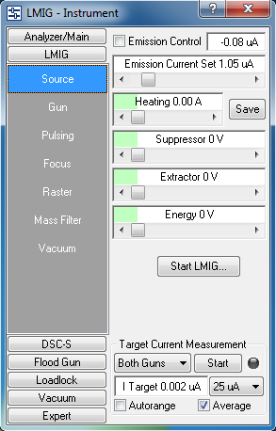

When the Bi start routine is complete, in the LMIG control window:

* Bi emission current should be locked at 1.05 µA
* all of the settings should be stable at their programmed values (i.e., green backgrounds for all parameters),
* Suppressor value should be 1000 V ± ~600 V
* Aperture 1 current should be ~18 – 25 nA

In the LMIG control window, click the button next to Aperture 1. This brings up a trace showing the beam profile. Click “Center” to automatically center the beam in the x direction. Select “LMIG Y_Source” from the menu at the bottom. Click “Center” to center the beam in the y direction (the trace should look like the image below). Repeat this process for Aperture 2 with the X_Mag and Y_Mag settings. If there is no current at Aperture 2, but Aperture 1 is normal, then check that the LMIG isolation valve is fully open. Note the Aperture 1 current in the desktop log file.

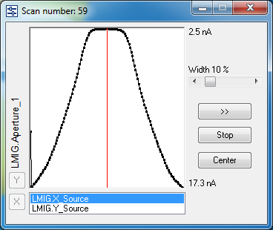

# Analyzer

To start the mass-spectrometer Analyzer section, do the following:

* Click loadsettings icon.PNG under Settings in the System Panel.
* Navigate to C:\Program Files\ION-TOPF\Surface Lab 6\settings\Analyzer. Choose the “Standard” settings file. You will see a popup window asking for which component you want to load the selected settings. Select “All” or “Selected”.

# Focusing on the Sample

If it is not already open, bring up the Navigator window by clicking navigation icon.PNG on the System Panel under Navigation. Check “Illumination” and “Micro” in the Navigator window.

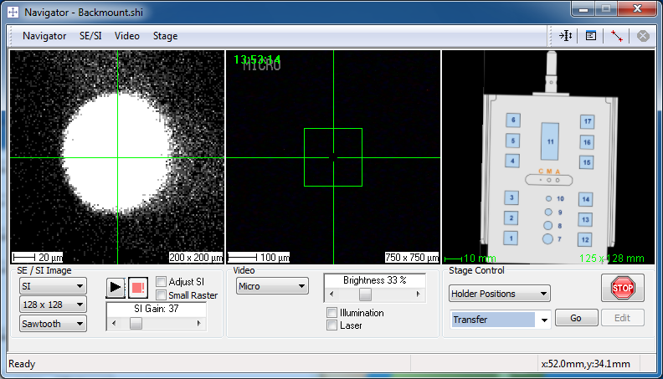

For the Backmount sample holder:

* In the right-most column, select the “A Grid” position and click “Go.” The stage will now go to the correct Z-height programmed for the Backmount sample holder. Check the alignment by verifying that the crosshairs align with the bottom left of the “A.”
* Move to the position of your sample by selecting its position from the dropdown menu and click “Go.” Select your area of interest by using the joystick to move the stage in X and Y. Because moving to the A-grid adjusts the Z-height, there should be no need to move in Z.
* Do the following three checks before starting a Raster scan:
  + 1 Disable the Sputter gun: If you have previously started the Sputter gun, you will see that it is checked in the System Panel. Uncheck it for this procedure
  + 2 Set the analysis area to the correct size: In the navigator window right-click on the SE/SI image (left-most) and select an area. For the focus procedure, select “Zoom All.”
  + 3 Determine which polarity ions you want to detect: In the instrument section of the F-Panel Use the pull-down menu to select Positive or Negative Ions.
* Start a Raster by clicking the start button below the SE/SI image. Adjust the Gain.
* Click the “Adjust SI” checkbox. The image will change to a circular spot, which needs to be centered on the crosshairs.
* Y Adjustment: To move it on the Y-axis, go to the Analyzer Panel and click on the “Y” slider. Center the spot using the mouse scroll wheel instead of dragging the slider for greater accuracy.
* X(Z) Adjustment: NEVER directly adjust “X” on the Analyzer panel. We will adjust X by fine-focusing Z. Because the LMIG is at an angle, sample movement in the Z-axis results in an X-shift of the region of interest (see schematic below).



For the Backmount sample holder, this adjustment can be done automatically. Right-click on the SE/SI window and select “Adjust Z”

* Uncheck Adjust SI, and stop the raster scan.

For the Topmount sample holder:

* The Topmount sample holder does not have a programmed Z-height because samples can have different thicknesses. The Z-height must be adjusted manually.
* Manually move the stage in X and Y using the joystick until the sample is under the detector. Then move the stage up in Z until the sample is about 5mm from the detector. Watch the stage through the port to ensure you do not hit the detector. Once close, switch to the Micro camera view and continue adjusting Z until the sample comes into focus.
* Do the following three checks before starting a Raster scan:
  + 1 Disable the Sputter gun: If you have previously started the Sputter gun, you will see that it is checked in the System Panel. Uncheck it for this procedure
  + 2 Set the analysis area to the correct size: In the navigator window right-click on the SE/SI image (left-most) and select an area. For the focus procedure, select “Zoom All.”
  + 3 Determine which polarity ions you want to detect: In the instrument section of the F-Panel Use the pull-down menu to select Positive or Negative Ions.
* Start a Raster by clicking the start button below the SE/SI image. Adjust the Gain.
* Click the “Adjust SI” checkbox. The image will change to a circular spot, which needs to be centered on the crosshairs.
* Y Adjustment: To move it on the Y-axis, go to the Analyzer Panel and click on the “Y” slider. Center the spot using the mouse scroll wheel instead of dragging the slider for greater accuracy.
* X(Z) Adjustment: NEVER directly adjust “X” on the Analyzer panel. We will adjust X by fine-tuning Z.
* With the joystick set to control the Z-axis, remember D = D, “**D**own = **D**angerous” (i.e., push Down to move the sample closer to the detector – go slow and be careful, push Up to move the sample further away). Carefully move the stage in the Z direction until the spot is centered.
* Set the joystick back to control X and Y. Uncheck Adjust SI, and stop the raster scan.

# Centering the Sputter Beam

For depth profiles, it is essential to center the sputter beam. If you are not doing a depth profile in this session and did not turn on the sputter gun, skip to the next section to start your scan.

* Move to a non-critical part of your sample as sputtering is a destructive process. Click the checkbox under Sputter Gun in the System panel
* In the Navigator window, right click on the SE/SI window and select “Zoom All”
* In the DSC-S control window, set the Raster Size to 50µm
* Back in the Navigator window, start a raster scan. After making sure that you can see an image, click the checkbox under Sputter Gun in the System panel
* The sputter crater will be a dark or bright spot that grows over time. Adjust the X-Target and Y-Target parameters in the DSC control window to center the etch spot in the ion image.
* Stop the raster, uncheck the DSC enable box, and go to a new test area. Restart the raster, re-enable the sputter gun, and confirm that the beam is centered.
* During analysis, the size of the sputter beam should be ~3 times the size of your analysis area. As an example, set the Raster Size in the DSC-S control window to 500µm and your Analysis area in the Navigator window to 150µm.
* Uncheck the Sputter Gun in the System Panel

# Starting a Scan

Survey Spectrum

The first step to collecting data is to perform a survey spectrum on the sample. This will allow you to initially calibrate the mass scale.

* Move to a new area of your sample
* Click icon-spectrum.PNG under Acquisition in the System Panel to open the Spectrum window. The spectrum acquired from focusing on your sample will already be there. You can also use this spectrum to calibrate if it is sufficient.
* Click icon-start scan.PNG under Acquisition in the System Panel to set the parameters for your Initial scan. Select a time limited acquisition set at 20-30s.
* Click Start. The system will accumulate counts for the set time.
* Bring up the calibration window by pressing F3 of going to Spectrum 🡪 Mass Calibration. Click on peaks in the spectrum, identify them, and add them to the calibration. For positive polarity, typical peaks are H+, H2+, C+, CH3+, Na+, and saturated hydrocarbons such as C3H8 (for negative polarity H-, C-, CH-, O-, F-, C2H-, and Cl are prevalent on unsputtered surfaces). If you have a heavier element(s) that you can definitely identify, this can greatly improve your calibration at higher mass numbers.)

You can now select peaks that you wish to track through your experiment. You can click on individual peaks in the spectrum window or use the search box in the upper left. When you select a peak in the zoomed view (lower right), and the select “Check” the ID window will display a dropdown menu of possible matches. Select the correct match, click “OK”, and then click “Add Peak.”

Once you have completed the scan and analysis click icon-endmeasurement.PNG on the System Panel to end the measurement and save.

Depth Profile

Once you have set up an initial calibration you can monitor the masses in your peak table as a function of etch level by setting up a depth profile.

* Move to a new region of your sample. Click the checkbox under Sputter Gun in the System Panel to re-enable the sputter gun. Confirm that your analysis area is ~1/3 the size of the sputter beam.
* Open the Depth Profile acquisition window by clicking icon-depth profile.PNG on the System Panel.
* In the same manner as the survey scan, click icon-start scan.PNG to bring up the settings for the acquisition. Depending on your needs, you can set a longer acquisition time for the depth profile, or uncheck the box completely and end the scan manually when you see a certain feature in the profile. Click Go to start the scan.
* If you did not select stop criteria, end your scan at the desired time by clicking the Stop Measurement button (image) in the system panel.

Once you have completed the scan and analysis click icon-endmeasurement.PNG on the System Panel to end the measurement and save.

Using the Flood Gun

If you are depth profiling an insulating sample, then you will need to use the flood gun to maintain an electrically neutral surface. Use the following procedure to activate and adjust the flood gun.

* Load the electron flood gun setting flood.tmt via icon-load settings.PNG. Usually there is only one setting covering all applications. Make sure that the Floodgun checkbox in the System Panel is checked as this activates the necessary timing.

Optimization of the ion/electron acceptance ratio can be done automatically. Right-click on the SE/SI window and select “Adjust charge compensation.” To adjust it manually follow the procedure below:

* You may also check the value of the extraction bias which is stored in the settings file of the electron flood gun. Appropriate values are -20 V for both polarities. As the flood gun electrons have an energy of about 20 eV, the extraction bias of -20 V makes sure that no flood gun electrons can enter the analyzer.
* Note: The extraction bias is stored in the flood gun setting as well as in the sputter gun setting. Therefore, the order of loading the settings is of importance. Please make sure that you apply the appropriate extraction bias.
* Move to the sample. Check for a reasonable sample height by bringing the sample surface into the focus of the optical micro camera view (fine tuning can be done later). Start a total ion image with full field of view in order to make sure that some secondary ions for optimization are transmitted. It may be necessary to increase the SI gain value.
* From the context menu in the position window select adjust CC. Push the start button and change the reflectron voltage in the opened dialog until the circular shape vanishes. Usually you have to go to positive voltages in the negative and to negative voltages in the positive SIMS polarity. Go back with the reflector voltage until you have the "original" intensity. From this point on add additional 20 V (+20 V for positive SIMS and -20 V for negative SIMS) to the reflectron. Now the circle should be nicely round with a sharp, well-defined edge. Click on the Stop button to finish the analyzer adjustment for the insulating sample.
* In some cases, in particular if multilayer targets are considered, it may be helpful to use a higher reflector voltage than usual (40 V to 50 V away from the cut-off edge) in order to compensate for changes in the electronic property of the sample during depth profiling.
* After adjusting for charge compensation it is usually necessary to make a fine tuning on sample height adjustment
* As the reduced extraction potential results in a non-defined "acceptance circle", do not use the adjust-z command before the adjustment for charge compensation is finished.

Ion Image

An element/compound map can be assembled during the analysis run or reconstructed afterwards from the saved data. If an element map is desired, click icon-image.PNG to open the Ion Image window. Proceed with your acquisition as normal. A signal map will be generated for each peak on your peak list in the Spectrum window. Images can be saved through a screenshot or by going to File 🡪 Print and selecting PDF. Even if this window was not open during the original acquisition, it is possible to generate an image by reconstructing the original data.

# System Shutdown Procedure

* Stop all measurements and save all data
* If the DSC was in use, load the DSC_off.tmt routine via icon-load settings.PNG to shut it down.
* LMIG: In Instrument Panel/LMIG section/Source subsection, change the “Emission Control” drop-down menu from “Auto” to “Manual”. Ramp down the components in the LMIG control window in the following order (SHELLLE is a useful acronym).
  + **S**uppressor
  + **H**eating
  + **E**xtractor
  + **L**ens Source
  + **L**ens Mag
  + **L**ens Target
  + **E**nergy
* Analyzer: In the control window, ramp down the voltages from highest (10 kV acceleration) to lowest (typically 1500 V photomultiplier).
* Turn off the Power supplies for each subsystem by unchecking the boxes in the Power section of the System Panel.

# Removing Your Sample

To remove your sample, follow the reverse procedure of loading your sample. Be careful not to touch the sample holder, tweezers, or screwdriver with your hands or dirty gloves.

* Move the stage to the transfer position by selecting “Transfer” and pressing “Go” in the Navigator window
* Open the load lock gate by pressing the corresponding button on the loadlock arm
* Use the transfer arm to pull the stage out of the analysis chamber and close the gate.
* Vent the loadlock by pressing “Off” on the loadlock arm.
* Remove the stage and set it into the mounting block. Close the loadlock and press “ON” to start the loadlock pump.
* Remove your samples from the stage. MAKE SURE TO RETIGHTEN ALL SCREWS!
* Turn the loadlock pump off and wait for the chamber to vent. Mount the stage on the loadlock arm and pump down the loadlock.
* Turn off “Illumination” and close the Navigator window.

Log your run on the desktop text file.

# Full Shutdown Procedure

* Power down PC
* Make sure O2 bottles are closed
* Fully close manual isolation valves on DSC and LMIG columns
* Press Red HV Cabinet power button
* Press Red Instrument power button

# Power Up Procedure

* Press Green Instrument power button.
* Start up PC
* If instrument was without power for a short time, pumps should start back up automatically.
* If pumps don’t start automatically
  + Click **Instrument** Button in FPanel window (middle of screen on right side)
  + Click **Analyzer** button, then **Vacuum** tab.



* + Click **Start** button (will not be grayed out when pumps are stopped)
  + Monitor progress in the **Vacuum Operation** button in the FPanel
  + After Main turbo is up to speed, Click **LMIG** button, then **Vacuum** tab



* + Click **Start** to start LMIG turbos
  + Click **DSC** button, then **Vacuum** tab, then **Start** to start DSC turbo.



* + Click **Start** under **Loadlock** in FPanel window or press **Loadlock On** on transfer arm to start loadlock.
* When prompted, fully open manual isolation valves on DSC and LMIG columns.
* Press Green HV Cabinet power button.
* Reopen O2 bottles if needed.