Operation Instruction for Thermo Almega XR Micro and Macro Raman Analysis System

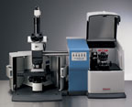

Thermo Scientific* Nicolet Almega XR provides top of the line performance and versatility—it is the Raman instrument to have when samples could be almost anything and speed of analysis is critical.
The Nicolet Almega XR Raman analysis system offers the ultimate in sampling versatility and performance. This instrument was designed for laboratories that are working on solving high-value problems where the ability to produce results quickly and to rapidly reconfigure to accommodate a wide range of sample formats is of critical importance. The Nicolet Almega XR supports micro as well as and macro sampling, multiple excitation lasers, and a number of automated sampling modes. Almost all reconfiguring of the system is done through software allowing the operator to toggle quickly between sampling modes. Multiple excitation lasers optimize the system for new samples
Capabilities
▪ Characterization and identification of small particles—as small as 0.5 microns. Great for ID of particulate contaminants.
▪ High-resolution depth profiling and subsurface analysis on transparent and semi-opaque samples. Excellent for characterizing coatings, multi-layer laminates, thin films, inclusions and subsurface defects.
▪ Organic and inorganic samples. The spectral range provides measurements down to 100cm⁻¹, which is of particular advantage for inorganics where the bands are typically at low frequencies.
▪ Molecular morphology characterization. Good representation of carbon and silicon molecular backbones provides great differentiation of pharmaceutical and mineral polymorphs as well as differentiation of amorphous and crystalline forms of silicon and many other materials.
▪ Automated data collection and analysis package for pharmaceutical polymorph recrystallization studies.
▪ Characterization of surface areas and subsurfaces are supported with x-y area maps and x-z maps.

Pre Checks:
Make sure that the “Power” and “Microscope” LED indicators on the system are On.
Laser Safety:

The Safety interlock on the door will shut the laser off when the door is opened. The “Laser-at-Sample” LED indicator should always be Off when you are manually adjusting your sample. If that is not the case, please close the doors and notify a staff member.

Operation Instructions:

- Loading a Sample:
  - Open the doors, use the joystick to move the stage out, put sample on the stage (try to load the sample near the exact center of the stage).
  - Move the stage back until your sample is located directly under the microscope. Choose the objective lens that you are going to use (caution: don’t let the lens hit your sample while changing magnification).
  - Turn on the power supply for the microscope lamp, focus on your sample by turning the knob under the stage, left knob is for coarse focus, right knob is fine focus. Locate your sample in the microscope and line up region to be scanned with the crosshair.
  - When you are done, close the doors – right hand first then left. Make sure they are properly nested and completely closed.

- Start Software Program:
- The Raman software is typically not left running, On the desktop double click the “Omnic For Almega” icon to open the program.
- When the software starts, there might be an error warning about the camera temperature in a pop up window and, the bench status indicator in the top right corner might show a yellow circle as shown in the upper figure below. Proceed with setting up the system and your sample. If after about 10~15 min, the warning indicator has not changed to green (lower figure below) then call a trainer.

- Set measurement spot.
  - Go to menu: Atlus show Atlus window: The live video appears in the right-hand window, adjust focus and move the stage with the joystick until the spot you want to measure is in focus and located right at the red cross in the center.
  - Go to menu: Atlus Move Stage, press the “Set Home to Current” button to reset the origin. You can move the stage with the “Move by Steps” function, the smallest step you can move is 1um
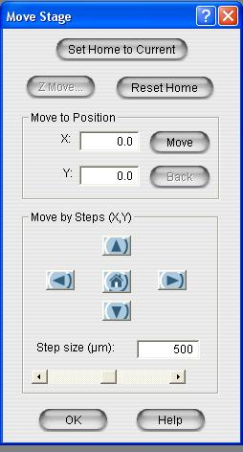
  - Set the calibration selection to the lens you are using by clicking the xX button near the bottom center of the screen. Select the objective that you are using to set the measurement scale.
  - If you want to do mapping for line, area and scattered points, click the corresponding button on the lower left hand corner on the screen, then click and drag on the video screen to define the mapping location.

- Setup Scan Parameters: click “Collect” on the top menu and select “Experiment Setup”. A menu will pop up on the screen as shown below
  - Click the “Collect” tab to set up the scan parameters. Check the box for ”Preview data collection”, and set the “Cosmic Ray Threshold” to “low”. Change the “exposure time” and “sample exposures” as needed. The number of “background exposures” must be larger than the number of “sample exposures”
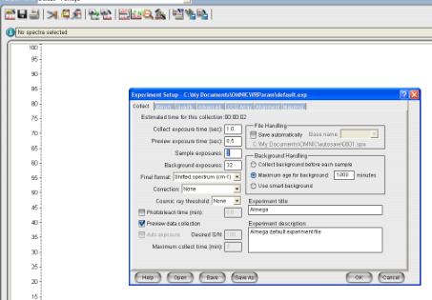
  - Click “Bench” tab to set up laser. Select the laser you need and turn it on (use the 488nm laser for most of the applications, use 785nm laser if the fluorescence is a problem for your experiment). Select proper aperture size, resolution and grating. Turn off the laser from this screen when you are done with your experiment. When the laser is fully powered on, you should see a spectrum in the preview section of the Bench window.
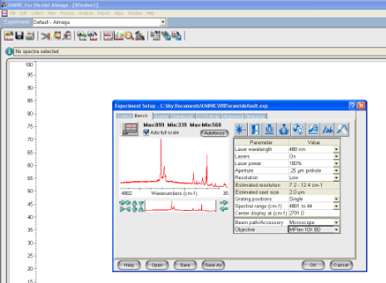

  - If you are planning to do a multipoint scan (linescan, Map, etc.), go to “Mapping” tab, and set the step size in each direction as shown below. Then go to the “Collect” tab and set up the capture parameters.
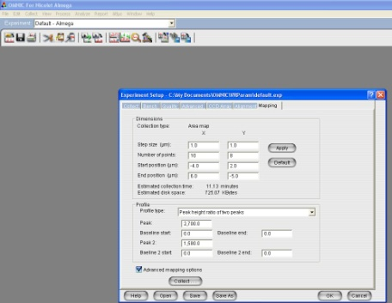
  - Do not change other settings without consulting with staff, or you might be responsible for serious system damage.

- Collect Sample:
  - Spectrum:
    - Click “collect” on top menu and select “collect sample” to start collecting.
    - Name your spectrum in the pop up window and click “ok” to start preview.
    - Use the focus knob on the joystick console to change the focus while looking at the scan data, try to get the maximum Raman intensity.
    - After it is done, click the “start collection” button on the top right corner.
    - When the collection is done, click “yes” to add the spectrum to a new window.
  - Map or other multi-point scan
    - Click “collect” on top menu and select “collect map” to start collecting.
    - Name your spectrum in the pop up window and click “ok” to start preview.
    - The system will show a video capture of the area to be scanned with the grid of measurement points overlaid.
    - The system will automatically move to the first point and begin data collection. An overview of the last 10 spectra is displayed.
    - When the collection is done, the map data will be automatically displayed.

- Save Data: Single spectra can be saved in the “native” .SPA file format or exported as .CSV data and/or TIFF image files. The .csv format can only save one spectrum per file, so if you have multiple spectra overlaid in one window, select each individual spectrum and save them one by one. Map data are saved as .map files. Individual spectra can be extracted with a little effort.
- Finishing: When you are done with the experiment, open the door, lower the stage using the joystick or the knobs, remove your sample from the stage, and move the stage center back to under the objective. Close the door, and turn off the light source. Go to “experiment setup”, and turn off the laser. Please do not close the program.

Dos:
- Remember to turn off laser when you are done.
- Remember to turn off the illumination when you aren’t using it (e.g., during long maps and when done).
- Try to put your sample as close to the center of the stage as possible

Don’ts:
- Touch the objective lens with your sample at any time (especially when changing lenses).
- Close the “OMNIC” program

