Area Scans/Chemical Maps using the Thermo XPS
The following instructions are to help optimize the data collection and data analysis of area scans using the Thermo K-Alpha XPS. While it is not mandatory to follow all – or any – of these recommendations, the steps here should make data collection and analysis more efficient and accurate. If you have any questions on any part of these instructions – PLEASE ASK! I won’t fault users for checking with me.
Setting Up the Area Scan:
- 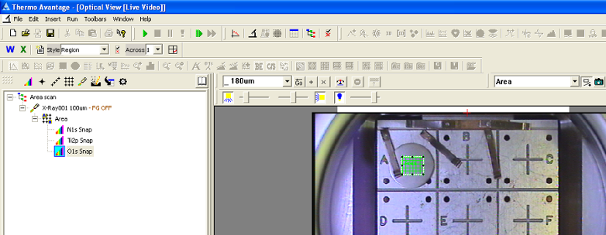As you set up the experiement you can add the area control by clicking on its icon or by choosing “Area” from the pull-down menu at the top right of the optical view and Shift+click or Ctrl+click on the stage image
- 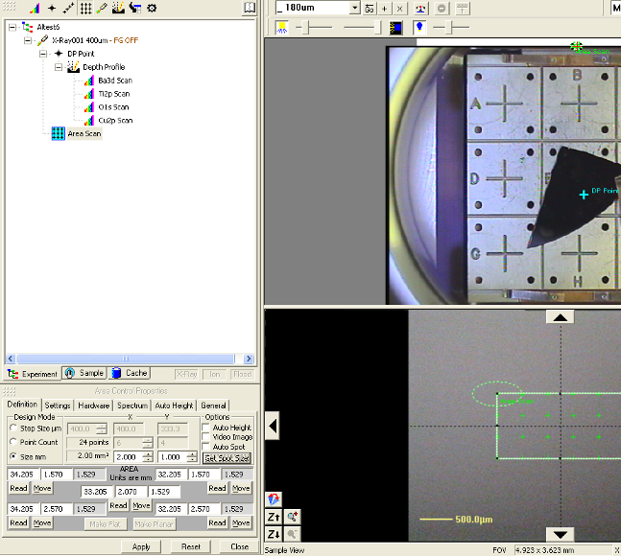Once the sample is in the analysis chamber and in focus, the most straightforward way to set up the area scan is to:
  - Click in the middle of the array of points using the crossed arrow cursor and drag it to center the scan on the area you want to map
  - Click on a corner – diagonal cursor should appear – and drag it to resize the scan area. Adjust the other corner to finalize the area.
  - If your sample is flat, then you can click on the button “Make Flat” to have all of the points at the same Z-height. If your sample has a tilt, then you can define different Z-heights for opposite corners and select “Make Planar” to have the system interpolate Z-heights for the points in between.
  - In the Area Scan properties, select “Step Size μm”, type in the step size that you want, and click “Apply”
  - Check the boxes to select “Video Image” and “Auto Height”
  - In the Auto Height Tab, you have the option of using 1 point (the center), 3 points (a triangle), or all points of the area for the auto height determination.
- 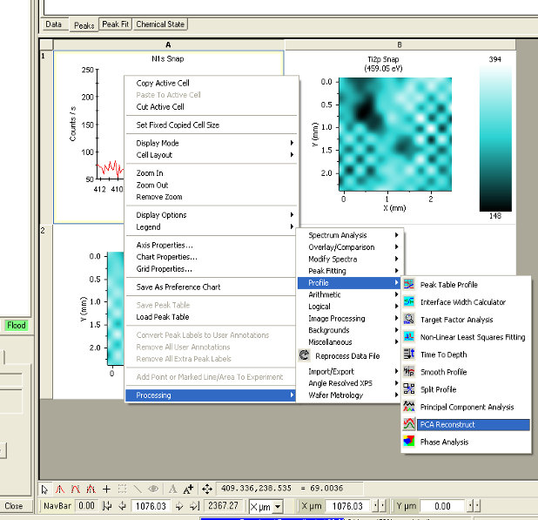Typically for a chemical map one wants to track the relative amounts of only a few elements as a function of position and will thus not need to do a survey scan at each point. This makes it convenient to use snapshot mode – which is much faster than scanned mode – to do the data collection. The speed becomes important if your area scan contains a large number of points. In the Multispectrum window, click the “snapshot” button to collect the single-element Hi-Res data in snapshot mode. The number of captures can typically be 1 – 3 ( at 1 second per capture) for elements of relatively high concentration (i.e., > ~5% for light elements and > ~1% for higher-Z elements).
Typically one will view area scan data as a color map where the x and y axes are the X and Y positions in the area scan grid, and intensity at a selected energy is given by a color table (see Ti2p data below). It is also possible to view data as traditional Intensity vs. BE single scans, which you step through in X and Y position to view data from a particular spot (N1s data below). One can toggle between these views using the Y-X and E icons, respectively, which are located just above the icon to add a depth profile to your experiment.
Once data has been collected in snapshot mode there are some software processing options available to enhance the signal-to-noise ratio and resolution of the data. As with any data processing tools, these should be used cautiously with an eye towards what is being taken from/added to the raw data.
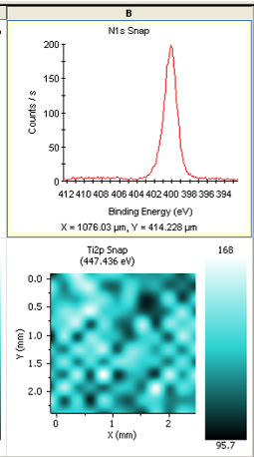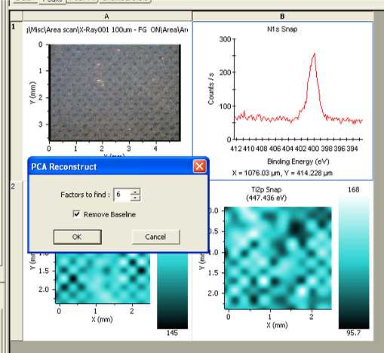To smooth the data in a “smart” way, one can right click on a particular set of high-resolution scans then select Processing/Profile/PCA reconstruct. A window will pop up asking how many “Factors to find”. The larger(smaller) the number of factors, the more(less) original information is represented and the less(more) smoothing occurs. When you click OK, the scans are processed to contain only the Principal components of the original data by removing “extraneous” information – usually(hopefully) noise – (see before and after images for N1s above).
If you used snapshot mode to capture your element-specific data, then it is also possible to offset some of the resolution loss by using an internal snapshot-to-scanned mapping function in the software. Select one of the Hi-resolution series, set the display to single scan. Then Right click and select Processing/Modify Spectra/Energy Deconvolution as shown above. The system uses empircal data taken from scanned and snapshot spectra of its internal standard to deconvolve the snapshot data.
- 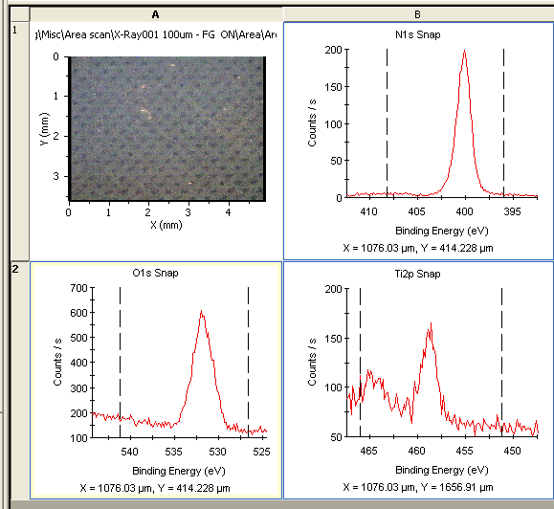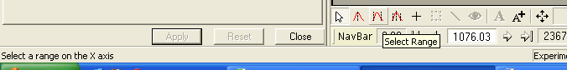To get an overview of the evolution of a peak as a function of etch time, you should set up a peak table profile. Before that you will need to have one or more peaks listed in the Peaks Tab of the Peak Table. If you have done a survey spectrum as part of the depth profile, then you can set it to Single scan display and click Survey ID to automatically have those peaks entered. If you have just single-element high resolution scans, then you will need to semi-automatically add them to the Peak list. To do this: Select all of the High- resolution scans of interest and set them to Counts/cps versus Binding Energy as shown above.
- Click the Select Range button at the bottom of the processing view (it is the icon with two black lines surrounding a red peak).
- In each of the High-Resolution scans, click once near the left and right edges of the window. This should create a set of dashed vertical lines spanning the energy range for that particular peak in ALL of the etch levels (i.e., don’t set the lines too close together).
- 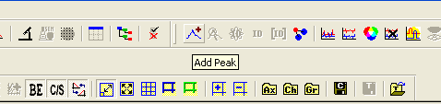Ctrl+click to select all of the elements that you want to include in the peak table
- At the top of the window in the Peak ID section click Add Peak
- 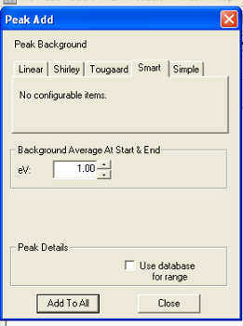In the box that pops up, you should have the option to “Add to All” at the bottom. If not, then you have only one element selected. Click Add to All to enter the peaks. The selected areas will be automatically scanned and the peaks will be added to the peak table – calculated separately for EACH of the points in the area scan – as shown below.

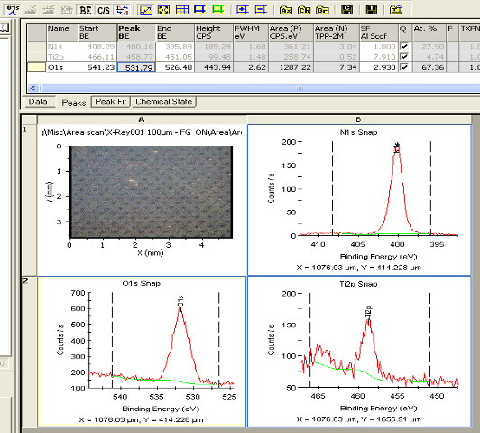To create a Peak Table Profile:
- In the peak table select the element(s) which you want to profile by Ctrl+clicking on the box(es) at the beginning of each row. Selected peaks will have an arrow in this box.
- Select Peak Table Profile from the top left set of icons.
- Typically you will display just the atomic percentage as a function of depth, but you can choose another property – e.g., position of one peak to see chemical shifts – from the check boxes.
- 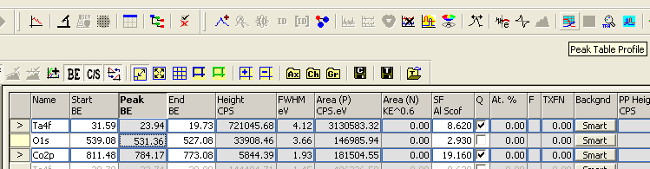Click OK and the Profile will be generated as shown below for the atomic percentage of N1s on a sample with a grid of ~100 μm PLL dots on a metal substrate.
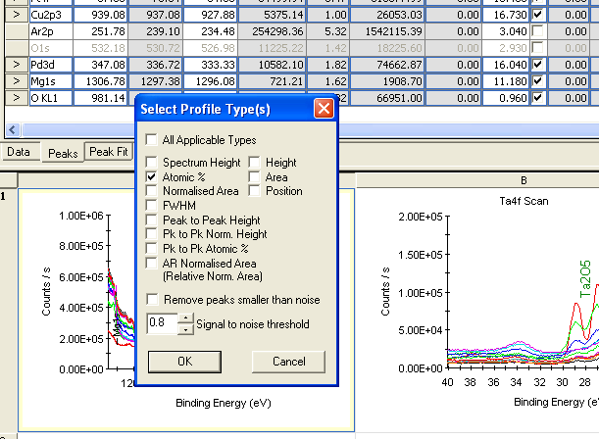

“Finally” It is possible to superimpose the chemical map data from the peak table profile onto the optical image of the scan area. To do this:
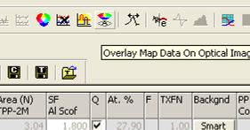Open the .vgd data files from the experiment – including the optical image of the area scan – and add them to a new processing view.
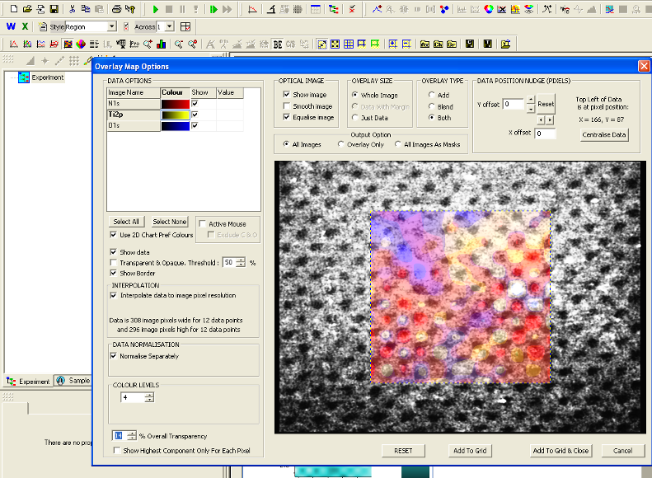Ctrl+click on the optical image and the peak table profile with the atomic percentage data. Click on the “Overlay Map Data On Optical Image” icon at the top of the window (Letter “A” in a circle with a multicolored disk above it). The properties window for the overlay settings will pop up as shown below. Adjust the setting to optimize the image then click Add to Grid and Close when you are finished. Your processing view will look similar to the grid shown at the bottom of the page.

OPTIONAL
Another option to select peaks for the peak table – and peak table profile – is to perform a target factor analysis of the high-res scans. This analysis extracts the minimum number of real scans – i.e., the “basis vectors” – taken from all the points in the area scan that can be scaled and/or shifted to reproduce ALL of the data. This can be used to select different chemistries of a given element present in the area being mapped. To start a target factor analysis, select one high-res data series and click the “TFA “icon at the top right of the main window. In the popup box click Start TFA. When the analysis is finished, it will open a new processing view with data on the element. Click Accept and the peaks will be added to the peak table of your original processing view. You can close (with or without saving) the processing view created by the TFA analysis and return to your original data. Creating a peak table profile using the new TFA peaks will allow you to see the variation in chemical state in one element across your scan area. Similar chemical state peaks could be added (semi)manually using the peak fit function instead.

