Join Us For Adventure!
Atlanta Summer Program 2018
Saturday, July 21 – Sunday, July 22, 2018

Experience two of America’s favorite pastimes -- Camping & adventure sports. No experience is needed. Join us for an exciting summer adventure. Enjoy swimming, sleeping under the stars, cooking out, campfires, music and more! ALSO pick one of these specialty adventures: Rafting or Hiking. (Rafting costs a little more).

“I enjoyed my weekend very much. Great fun! This was the first time that I slept outside; the first time that I saw hundreds of stars in the sky; the first time that I ate Marshmallow and I love it!!!” -- 2011 participant.

We’ve done our best to make this adventure convenient and affordable. We’ll provide meals ~ Sat. lunch through Sun. dinner; equipment like tents, sleeping bags; transportation; and experienced guides.

BASIC SCHEDULE

Saturday, July 21, 2018
- Meet at the Georgia Tech Residence Halls (8:30 am)
- Drive by van to Outdoor Adventure Rafting (OAR) campsite, Ocoee River, Tennessee.
- Set up tents, etc.
- Swimming , games, & sightseeing
- Cookout Dinner
- Campfire/Music/ Stories /Roasting Marshmallows
Sunday: July 22, 2018
- Breakfast
- Take down tents & pack gear
SPECIALTY ADVENTURES: Hiking or Rafting
- Dinner
- Drive back to Georgia Tech

SPECIALTY ADVENTURES: Choose One

OPTION 1: HIKING
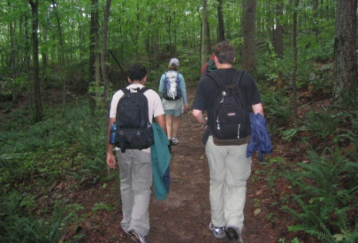
Join us on a moderately strenuous 8-mile hike through the Tennessee hills. Hike 5-6 hours near the Ocoee River. This is a great opportunity to get some exercise, see a wonderful array of plant-life and geology, and to enjoy scenic Tennessee. Play in a great waterfall and swim in the crystal clear lake afterwards.

You must be in good physical condition and have sturdy shoes for walking. See the “What to Bring” list for more details. You do not need specialty equipment. You must have sturdy walking shoes.

OPTION 2: WHITEWATER RAFTING
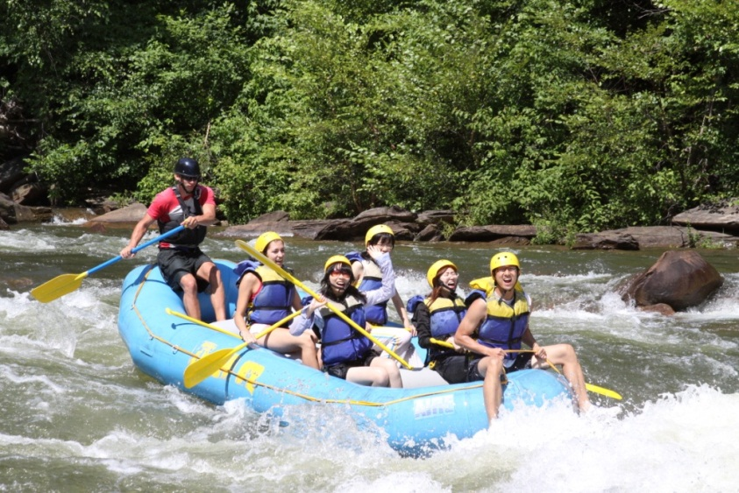
Join us for some fun & excitement on the Ocoee River. This is a one of the best whitewater rafting streams there is! Certainly the best in the southeastern United States and easily one of the top 5 rafting rivers in America.

If you are comfortable with your swimming skills, and like high adventure, this trip is for you. You are sure to get wet and laugh a lot. This trip will be professionally guided by OAR River Guides, http://www.raft.com/ with Georgia Tech students along, too.. You will be asked to sign their liability/legal forms before getting on the river.

You must be in good physical condition and be able to swim reasonably well. The Upper and Middle sections of the Ocoee River are over 8 miles of continuous Class III and IV whitewater.

Before deciding on whether to sign up, please view the video here: http://www.raft.com/.

Questions? E-mail david.knobbe@crc.gatech.edu.

HOW TO DRESS / WHAT TO BRING
Atlanta Summer Program Outdoor Adventure Experience
July 21 - 22

You don’t have to have experience in the outdoors to have fun on this trip. It’s not meant to be overly demanding physically. This is an introductory level experience. Still, paddling in remote areas, CARRYING gear & boats, hiking miles at a time, are considerably more strenuous than an average day on the Georgia Tech campus. Knowing your limitations & being well prepared are important parts of successful adventuring.

Most people own clothing that is adequate for an experience such as this. We do not want you to run out and purchase specialty gear just for this trip. It is very important, however, that you have the right shoes for this trip. Don’t wear sandals. If you don’t own the right shoes or clothing, you can often find inexpensive options at discount stores like Wal-Mart or used clothing stores like Goodwill Industries.

Georgia Tech (or the rafting outfitter) provides group gear & supplies including tents, sleeping bags, sleeping pads, stoves, food, cooking pots, first aid equipment, and PFD’s.

You must provide clothing which is appropriate for outdoor activities and the specific adventure you have chosen. Equipment you will need may include items like hiking boots, water shoes, synthetic shirts, nylon pants (zip-off convertibles recommended), synthetic underwear, waterproof rain jacket & pants, a jacket, and a broad-brimmed hat.

You should bring bug repellent, sunglasses, a small towel, toiletries, sunscreen, prescription meds as needed, hygiene wipes, & a water bottle. A camera is optional.

How to Pack

- Pack smart! Pack light! You won’t need much!
- Bring your gear in a soft-sided duffle or backpack.
- Georgia Tech cannot accept responsibility for your belonging.
- Sturdy hiking shoes are a must if you are hiking. Secure fitting shoes that can get wet and muddy are needed for rafting.
- The less cotton, the better. Synthetic fabrics like nylon and polyester (high-tech wicking fabrics) are more comfortable in the outdoors than cotton.
- Be prepared for the weather. Expect it to be hot and sunny during the days. With a chance for rain anytime.
- Remember: Whatever you bring could get wet and muddy.

BASICS THAT EVERYONE SHOULD BRING:

- At least one full change of clothes for the ride home on Sunday (Pants, underwear, shirt, shoes, socks, etc.)
- Light jacket (We’ll provide single use rain jackets if needed.)
- Something to sleep in – It will most likely be warm at night.
- Swimsuit
- Hat & Sunglasses
- Sunscreen
- Bug Repellent
- Towel
- Soap, toothpaste & brush, etc. There are showers available. No hair dryers, etc.

SPECIALTY ADVENTURES: WHAT TO BRING
- RAFTING: Gear that can get wet and provides sun-protection as needed.
- Nylon swim suit or trunks
- T-shirt
- Long-sleeved shirt for sun protection (layered with a synthetic t-shirt underneath if cool)
- Sturdy, water shoes that can get wet and won’t come off in rough water. Flip flops are not allowed.
- Sunglasses with strap (or a secure glasses-strap if you must wear glasses on the water)
- You will need a complete change of clothing – including an extra pair of shoes.

- HIKING: Gear that can get wet and provides sun-protection as needed.
- Sturdy hiking shoes (That tie – no slip-ons or sandals.)
- Nylon shorts or long pants
- Hat & sunglasses.
- Long-sleeved shirt for sun protection (layered with a synthetic t-shirt underneath if cool)
- Sturdy, water shoes that can get wet and won’t come off in rough water. Flip flops are not allowed.
- Sunglasses with strap (or a secure glasses-strap if you must wear glasses on the water)
- You will need a complete change of clothing – including an extra pair of shoes.

Prohibitions
- Do not bring alcohol, drugs, firearms, or fireworks.
- Tablets, Ipods, etc. are fine when traveling, but please leave them behind during activities.

Questions?

david.knobbe@crc.gatech.edu.
If you are a vegetarian, please send an e-mail to the above address.

